Linear Classification Perceptron

# Linear Classification

* Imagine you have data as shown on the right and you want to propose a class separating hypothesis.

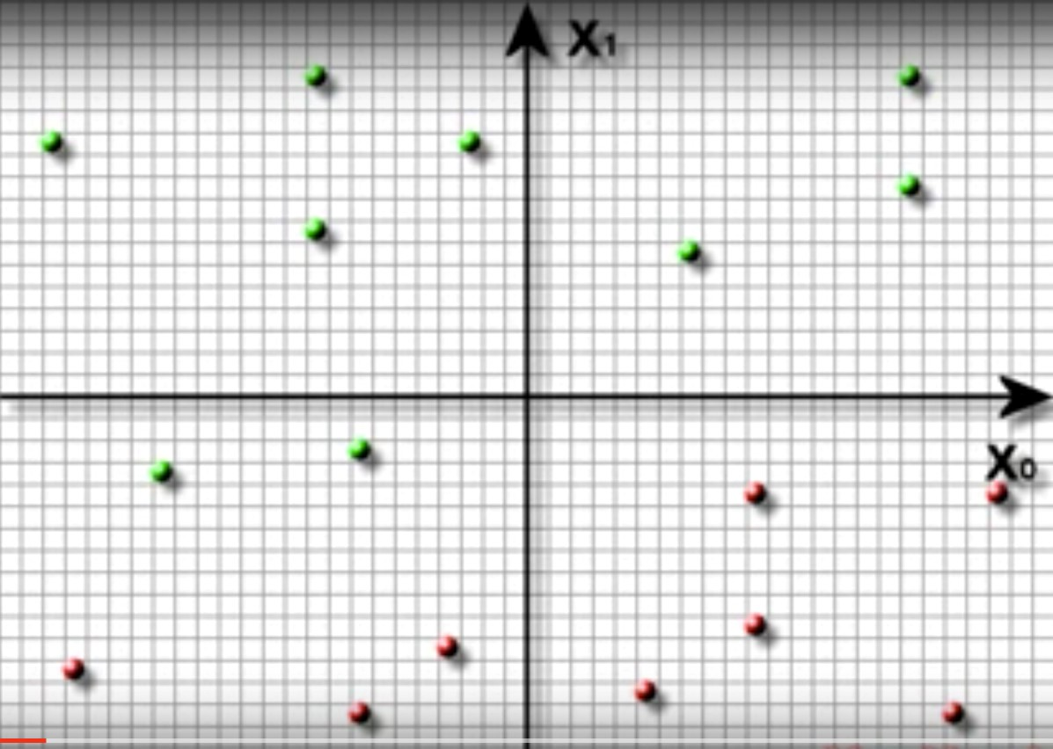

Your hypothesis

(

h

)

* Since data is linearly separable, you can propose a straight line
* Your hypothesis divides the plane into two parts
* Aim: Get those parts as pure as possible

Linear Classification

* 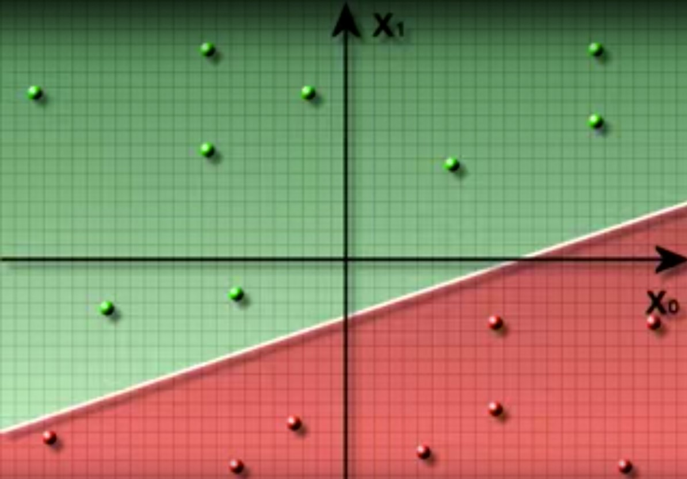OK, sounds simple enough
* Just draw a straight line and partition the plane into two parts.
* Limitations:

- Works with linearly separable data only.

* I can draw many lines that separate the data perfectly, which one do I choose?
* Good Question J

# Let's do some Math

* Equation of a straight line in a plane with two dimensions x1 and x2:

!"#"+!%#% ='

* There are three parameters in the equation above w1, w2 and ϴ.
* By changing these, you can get a different line.
* Let's call the hypothesis as:

( # =!"#"+!%#%−'

* What's the value of g for points that lie on the separating line? 0

# Math

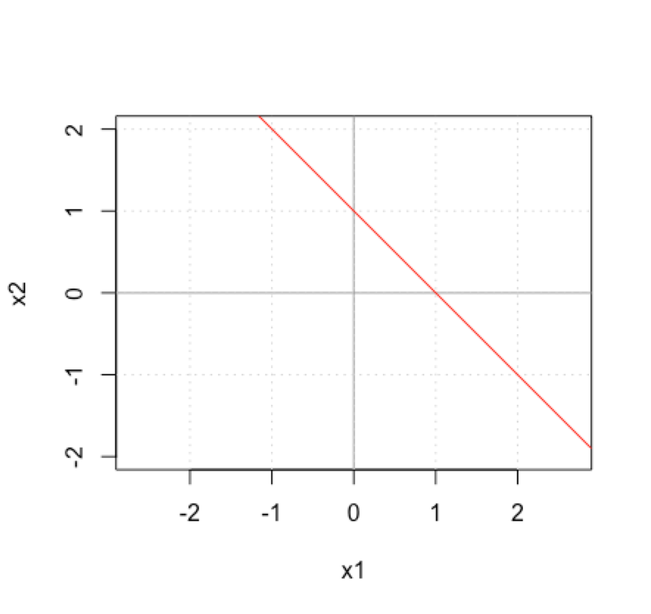

* Let's draw a line with w1 = 1, w2 = 1 and ϴ = 1.
* We are trying to draw:

!"+!$ =1

* Thus, g(x) = x1 + x2 - 1
* What are some points on this line: (1, 0), (0, 1), (½, ½), (-1, 2), …
* All the above points satisfy g(x) > 0
* Let's see what happens to points in green area.
* What is g(2, 1) ? g(2, 1) = 2 + 1 – 1 = 2

# Math

* Let's see what happens to points in red area.
* What is g(-1, -1) ?

g(-1, -1) = -1 - 1 – 1 = -3

* So, what can we use as a classification rule:



* Check sign of hypothesis for test data point:

if sign(g(xtest)) > 0 call it class +1 else if sign(g(xtest)) < 0 call it class -1

# Classification Rule

* Let h(x) denote the sign of g(x) h(x) = sign(g(x))

sign(x) function is defined as +1 for x >= 0 and -1 for x < 0

* Predicted class label:

Class = h(x)

# Linear Classification

* If there are n input attributes x1, x2, …, xn, our task is to find appropriate set of weights w1, w2, …, wn, such that correct classification can be performed.
* We would like if ∑%"#$ &"'" - ϴ > 0 then class = +1 otherwise class = -1 for some threshold value ϴ.
* This can be states as: If **w**T**x** > ϴ then class= +1 otherwise class = -1 where **w** is the weights vector and

Note: i starts from 1 => We don't have any artificial attributes

**x** is the attributes vector.

# Linear Classification

• Can be written as: You will find both

w1x1 + w2x2 + … + wnxn > ϴ for class +1 these forms used in

or textbooks

- ϴ + w1x1 + w2x2 + … + wnxn> 0 for class +1

or w0 + w1x1 + w2x2 + … + wnxn> 0 for class +1 where w0 is referred to as the bias term.

# Linear Classification

• Two equivalent ways:

!'

"#>% where != !…( !

!*

!,

!'

!"#>0 where != !(

…

!*

#' You will find both

#( these forms used in #= … for class +1 textbooks

#*

#,

#'

#= #( for class +1

…

#*

# Graphical Meaning of Terms

* What do the terms (w1, w2, ..) and ϴ mean graphically.
* w's correspond to the slope and ϴ is a measure of intercept of the line.

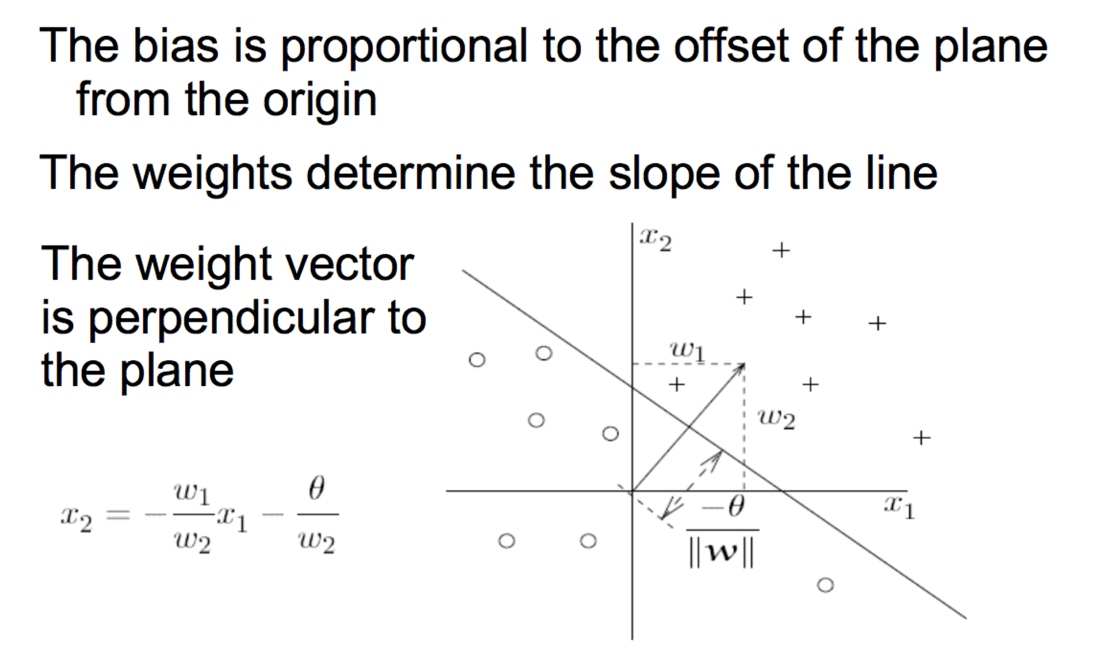

# Perceptron

* The idea of linear threshold classifier is used in the model of a perceptron.
* Inspired by bio-computing model of a neuron in brain.

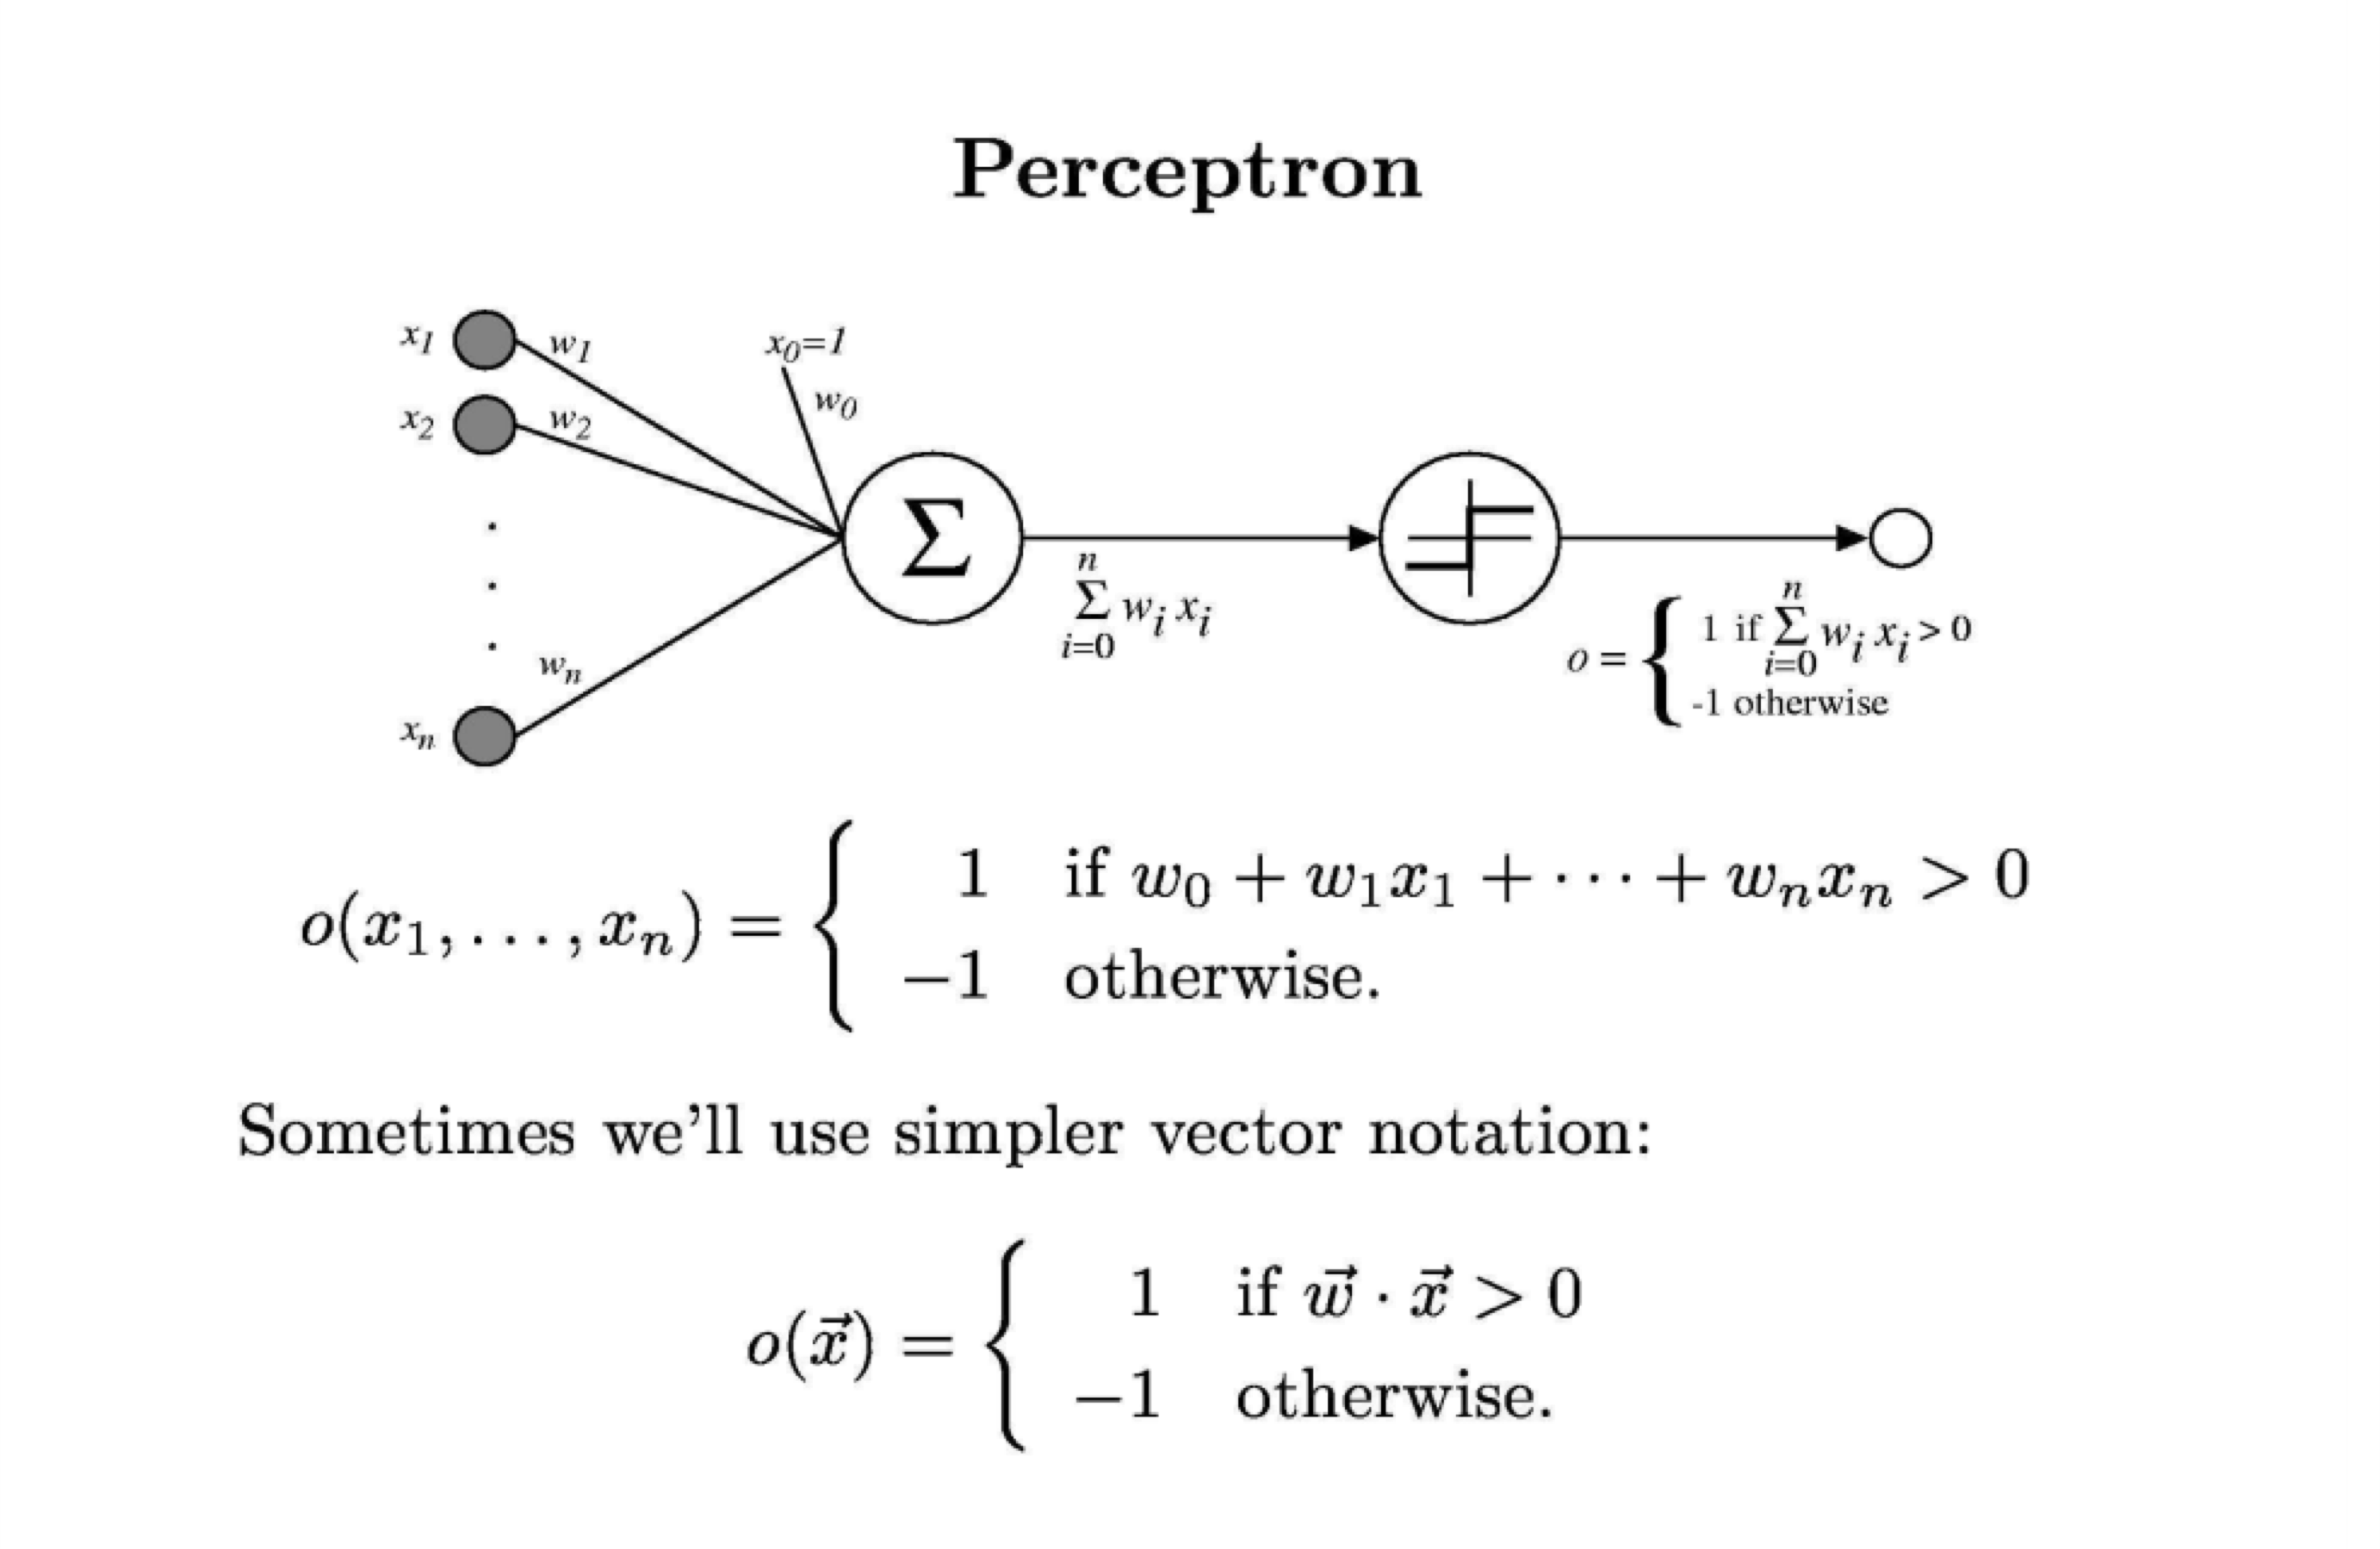

Summing

Machine

Decision Machine using

thresholding

function

# Linear Classification

* The hypothesis can be represented as:

h(x) = s(g(wTx)) where s is a function that outputs -1 or +1

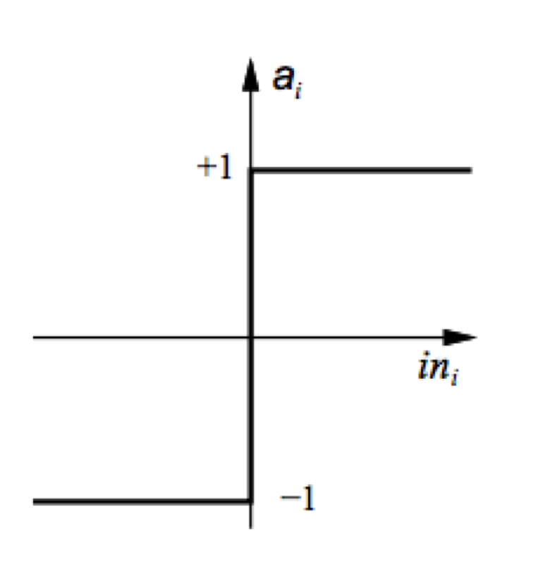What can s be?

s(x) = +1 if x >= 0

-1 if x < 0

It's called the sign function

Types of problems Perceptron can solve

* 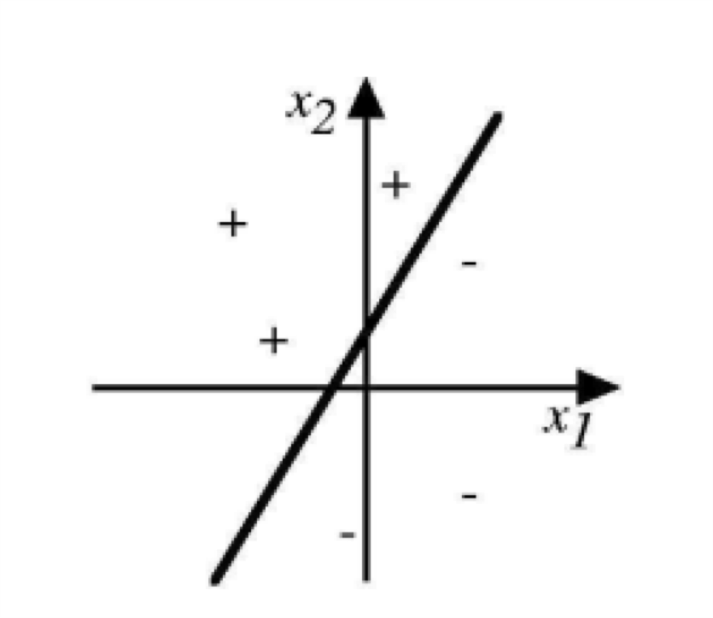Linearly separable dataset only.
* If you use it with non-linear data, you will not get 0% training error.

=> You will not get a consistent hypothesis on non-linear dataset

* Let's see some examples of its representational power.
* Let's see if we can represent the AND function.
* Perceptron model: if w1x1 + w2x2 > ϴ then Class = +1 else class = -1
* Let's assume w1 = w2 = 1. You can vary ϴ.

|  |  |  |
| --- | --- | --- |
| **x1** | **x2** | **Class** |
| -1 | -1 | -1 |
| -1 | 1 | -1 |
| 1 | -1 | -1 |
| 1 | 1 | 1 |

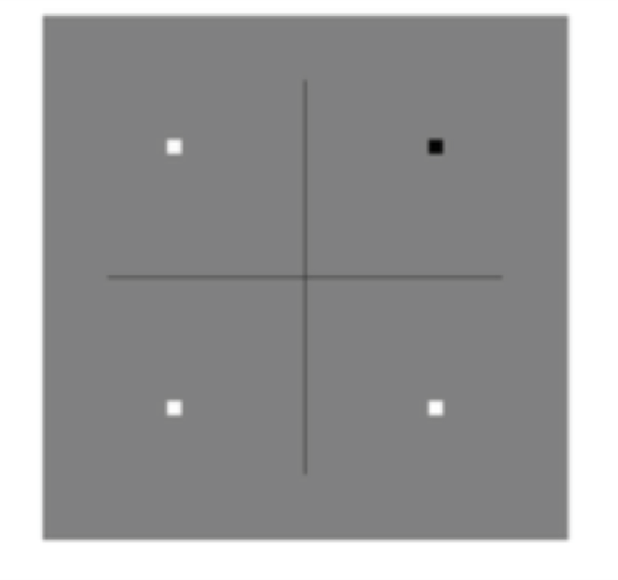if x1 + x2 > ϴ then Class +1

else class = -1

* Find the value of ϴ
* Any number greater than 0 and less than 2

e.g. 1.5

* Another way of representing AND.

|  |  |  |
| --- | --- | --- |
| **x1** | **x2** | **Class** |
| -1 | -1 | -1 |
| -1 | 1 | -1 |
| 1 | -1 | -1 |
| 1 | 1 | 1 |

* 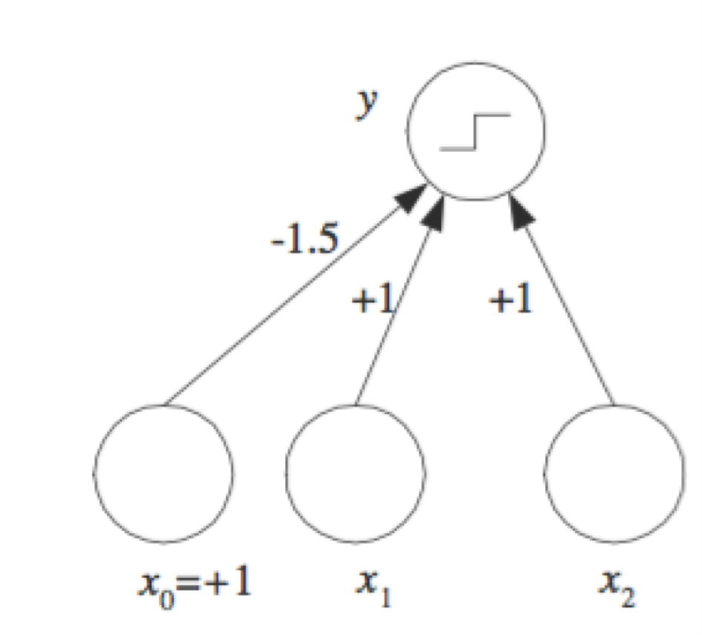Perceptron model: if w0 + w1x1 + w2x2 > 0 then Class = +1 else class = -1

Notice: w0 = - ϴ

* Let's assume w1 = w2 = 1. You are looking for w0 such that : if w0 +x1 + x2 > 0 then Class +1 else class = -1
* What is w0 ?

Any number less than 0 and greater than -2 e.g. -1.5 or -0.5

Figure 11.4 of Intro to ML textbook

|  |  |  |
| --- | --- | --- |
| **x1** | **x2** | **Class** |
| -1 | -1 | -1 |
| -1 | 1 | 1 |
| 1 | -1 | 1 |
| 1 | 1 | 1 |

* Let's see if we can represent the OR function.
* Perceptron model: if w1x1 + w2x2 > ϴ then Class = +1 else class = -1
* Let's assume w1 = w2 = 1. You can vary ϴ. if x1 + x2 > ϴ then Class +1

else class = -1

* What is ϴ ?
* Any number less than 0, but greater than -2.

Example: -0.5

|  |  |  |
| --- | --- | --- |
| **x1** | **x2** | **Class** |
| -1 | -1 | -1 |
| -1 | 1 | 1 |
| 1 | -1 | 1 |
| 1 | 1 | 1 |

* Another way of representing OR.
* Perceptron model: if w0 + w1x1 + w2x2 > 0 then Class = +1 else class = -1

Notice: w0 = - ϴ

* 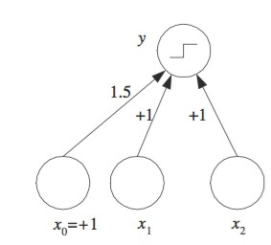Let's assume w1 = w2 = 1. You are looking for w0 such that : if w0 +x1 + x2 > 0 then Class +1 else class = -1
* What is w0 ?

Any number greater than 0, but less than 2.

Example: 0.5 or 1.5

* 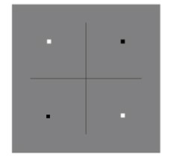Let's see if we can represent the XOR function.
* Perceptron model: if w1x1 + w2x2 > ϴ then Class = +1 else class = -1

|  |  |  |
| --- | --- | --- |
| **x1** | **x2** | **Class** |
| -1 | -1 | -1 |
| -1 | 1 | 1 |
| 1 | -1 | 1 |
| 1 | 1 | -1 |

* Let's assume w1 = w2 = 1. You can vary ϴ.

if x1 + x2 > ϴ then Class +1

else class = -1

* What is ϴ ?

Can't find any such value

History of Neural Networks

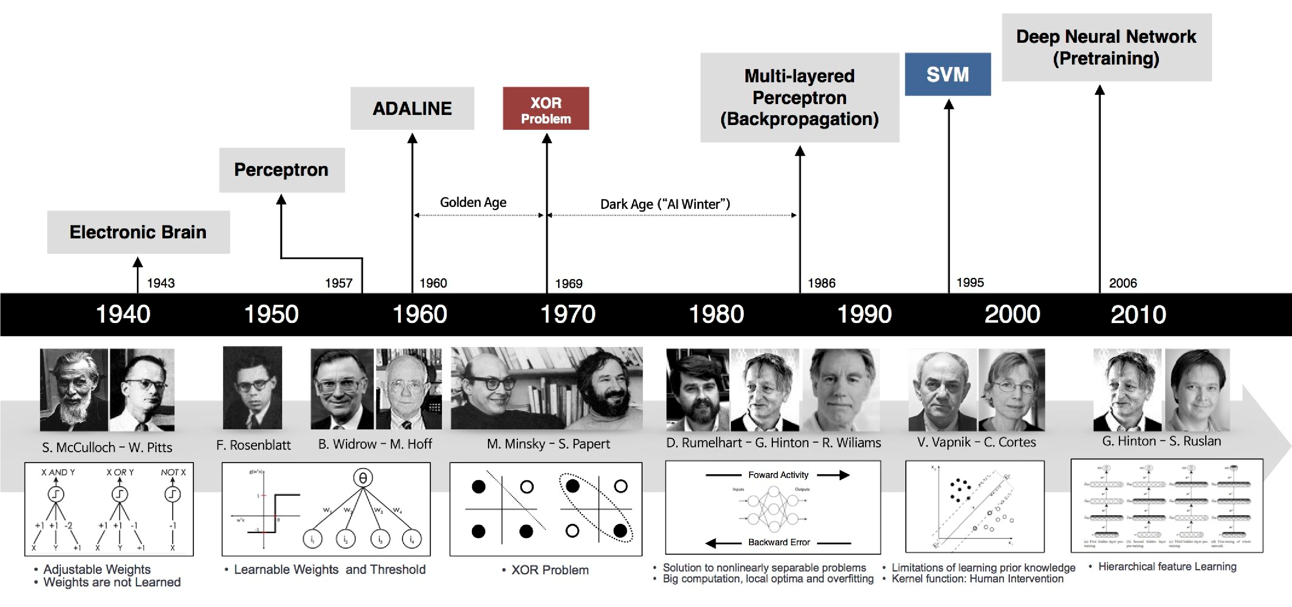

Image

from

https

:

//

mc.ai

/neural

-

networks/

Canonical Representation

* In our framework, when do our hypothesis and actual value agree?
* Sign function plays a big role.
* Let's consider possible cases:

|  |  |  |
| --- | --- | --- |
| **Hypothesis Prediction (h)** | **Actual**  **Class (y)** | **Correct?** |
| -1 | -1 | Yes |
| -1 | 1 | No |
| 1 | 1 | Yes |
| 1 | -1 | No |

So, what do you conclude: (h * y) should be > 0 for correct prediction

Some textbooks write it as:

g = wT x h = sign(w)

Check sign(h * y) for correct prediction

# Perceptron

* So, the functional form of the hypothesis is given to you: g(x) = wT x
* You classify a point based on sign(g)
* But the big question:

How do you find weights?

* That's why companies are looking for you.

# Learning Weights of a Perceptron

• Two techniques available: (Tom Mitchell 4.4.2 and 4.4.3)

1. Perceptron Training Rule – Change training weights according Perceptron

to: Training Rule

!"#$ = !&'( +∆! only works for

linearly

where ∆! = +,−./0 separable

Start with random weights and apply above rule to each training data.

example and modify each weight wi according to above rule.

+ is the learning rate

t is the target value that you want (given for training

examples) o is the current output of the perceptron.

Note: t and o can only have values in the set {-1, +1}

# Learning Weights of a Perceptron

• Two techniques available: (Tom Mitchell 4.4.2 and 4.4.3) This works

2. Gradient Descent Rule – First consider unthresholded output even if the of the perceptron: data is not

o = **w** . **x** linearly

Specify an error function: separable

! " = $%∑'∈)*' −,'%

where *D* is the set of all training examples.

Just like before, run the gradient descent algorithm on this function by starting with random weights.

1. Perceptron Training Rule Example:



* Given:
  + A set of instances X1, X2, …, XD each containing n attributes i.e. Xi = <x1, x2, ..., xn>

* For LC, we assume the binary attributes can take values of +1 or -1 *

* + Labels for each instance y1, y2, …, yD (can be +1 or -1)
* Example: UTD Internship Problem

|  |  |  |
| --- | --- | --- |
| **GPA > 3.5 (x1)** | **Exp > 2 yrs (x2)** | **Internship (y)** |
| 1 | -1 | -1 |
| 1 | 1 | 1 |
| -1 | 1 | 1 |

Can each attribute have different weight?

I want to give twice the weight to work experience as GPA.

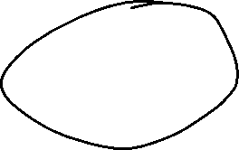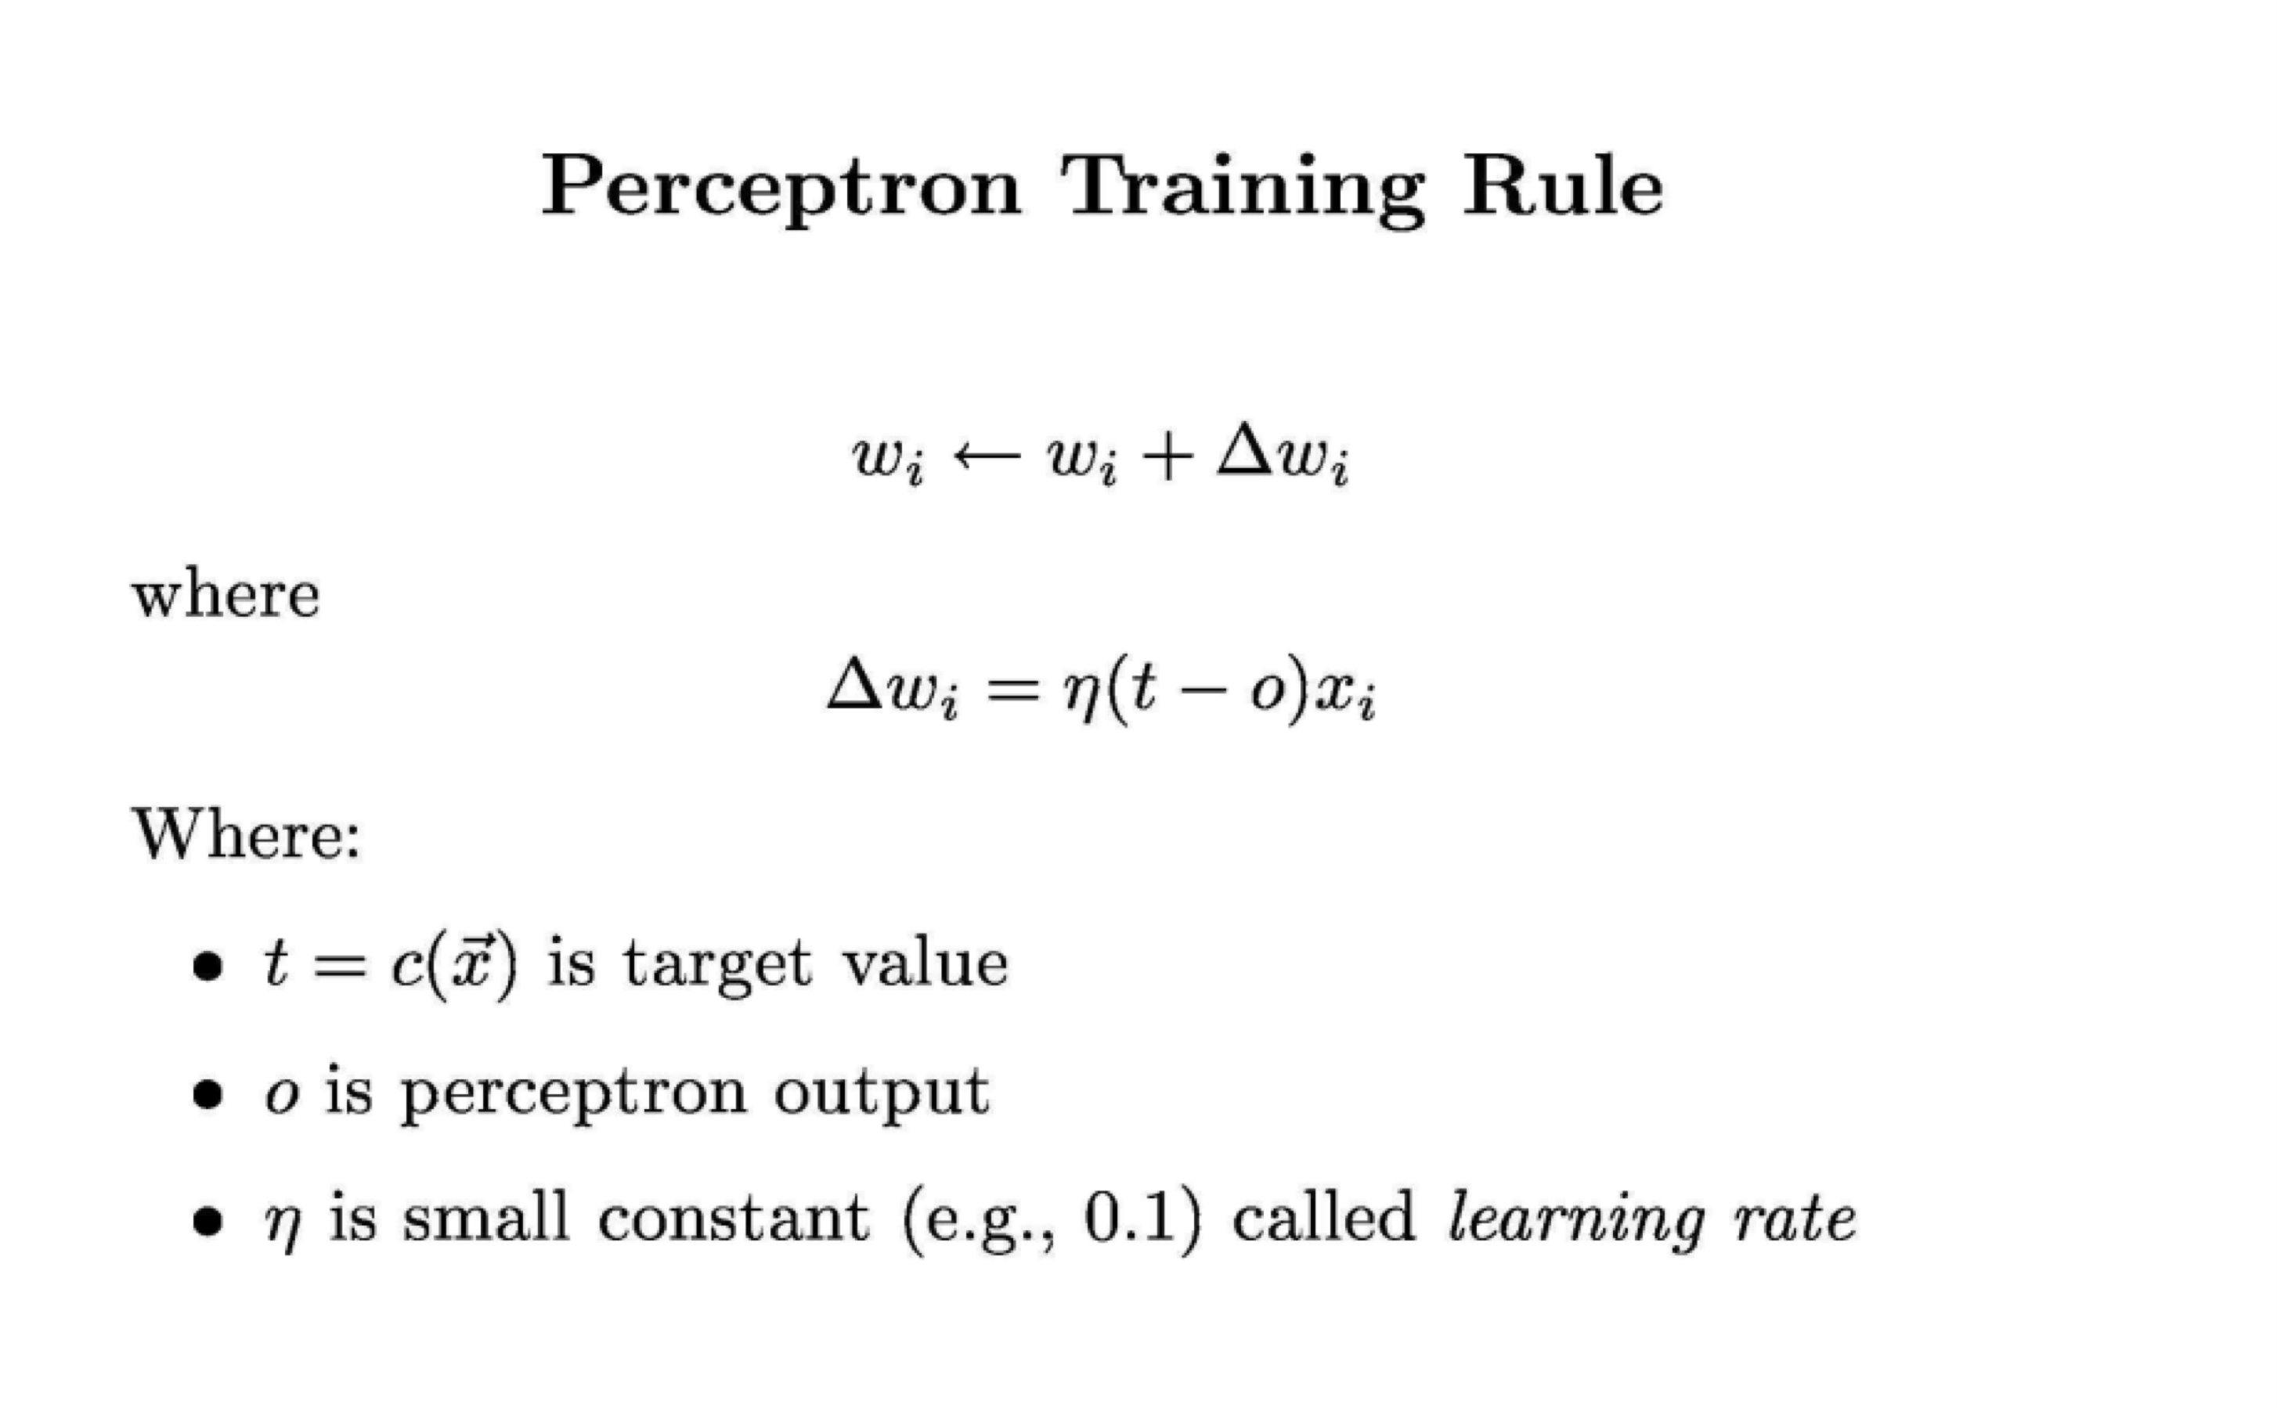

This is the practical rule

that you will use to train

a perceptron

Perceptron Training Algorithm

Perceptron_Training_Algorithm(training_examples, !) {

Initialize weights vector w to some random value

Until convergence do {

For each training example {

Compute output o using activation function

For each linear unit (attribute) *i*, update using

"#= "# + % & −( )#

}

}

}

# Convergence

Will it converge?

Yes, provided:

* Data is linearly separable.
* The learning rate is small enough.
* You initialize the weights vector as:w= −212



Assume a learning rate $ = 0.5. You are given following data points and target values:

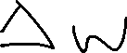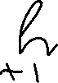

|  |  |  |
| --- | --- | --- |
| **x1** | **x2** | **t** |
| 0.5 | 1.5 | +1 |
| -0.5 | 0.5 | -1 |
| 0.5 | 0.5 | +1 |

* For first point,

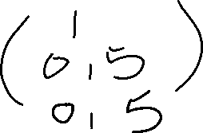

g(x) = sign(w.x) = sign(-2 + 0.5 +3) = +1

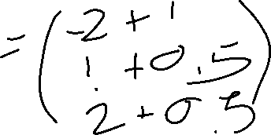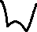

=> no change needed since t(x) = g(x)

* For second point,

g(x) = sign(w.x) = sign(-2-0.5+1.0) = -1

=> no change needed since t(x) = g(x)

* For third point,

g(x) = sign(w.x) = sign(-2+0.5+1.0) = -1

=> Need to update weights

* Updating weights. Start with Δ"=0; t - o = 1 - (-1) = 2

Δ"%= 0.5 * 2 * 1 = 1

Δ"&= 0.5 * 2 * 0.5 = 0.5 Δ"'= 0.5 * 2 * 0.5 = 0.5

So new values will be:

w0 = -2 + 1 = -1.0 w1 = 1 + 0.5 = 1.5 w2 = 2 + 0.5 = 2.5 So new values will be:

w0 = -2 + 1 = -1.0 w1 = 1 + 0.5 = 1.5 w2 = 2 + 0.5 = 2.5

You can verify that this value of the weights vector will classify points correctly.

Example 2

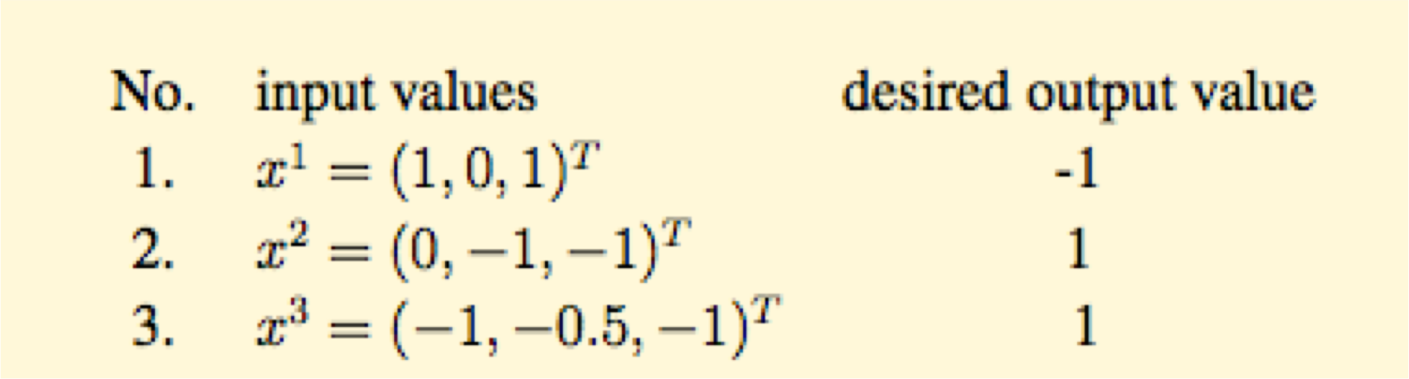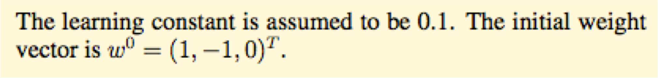

Example 2

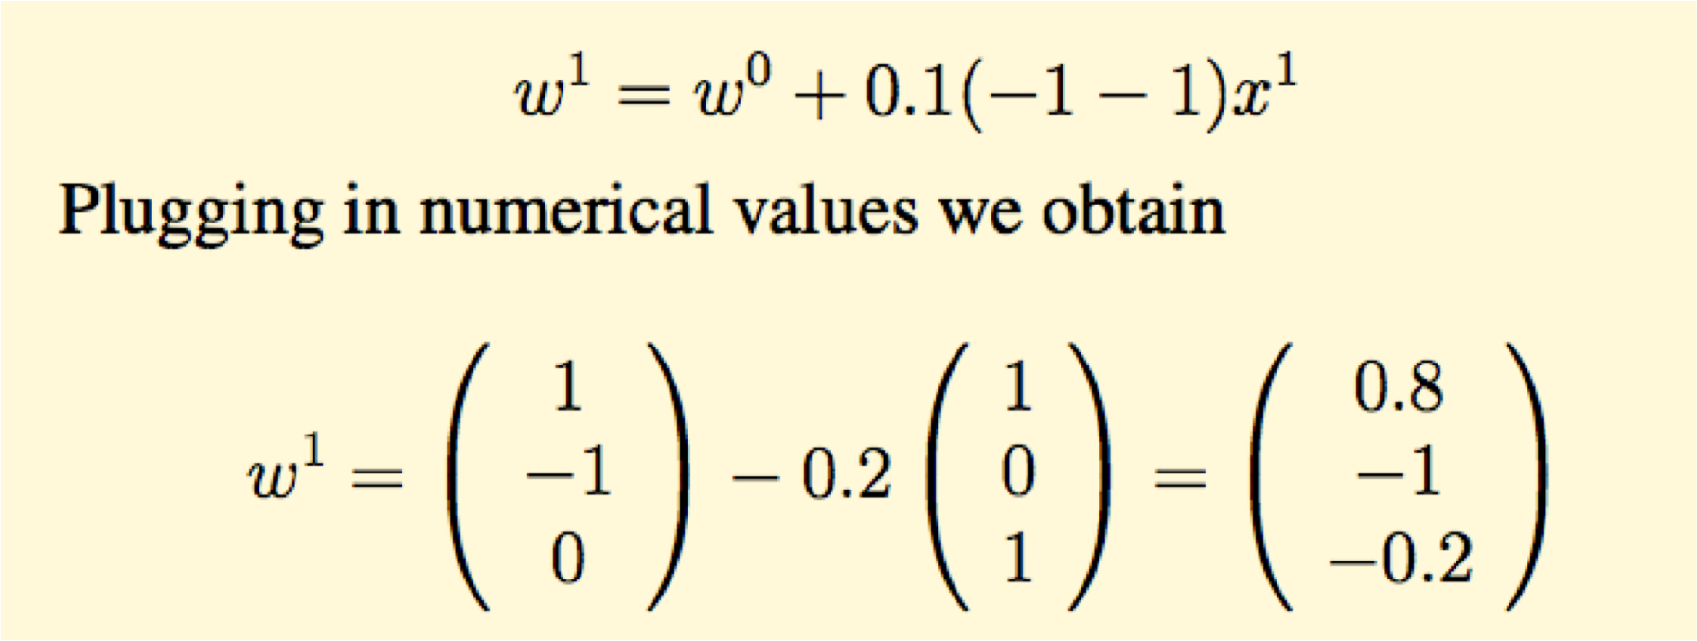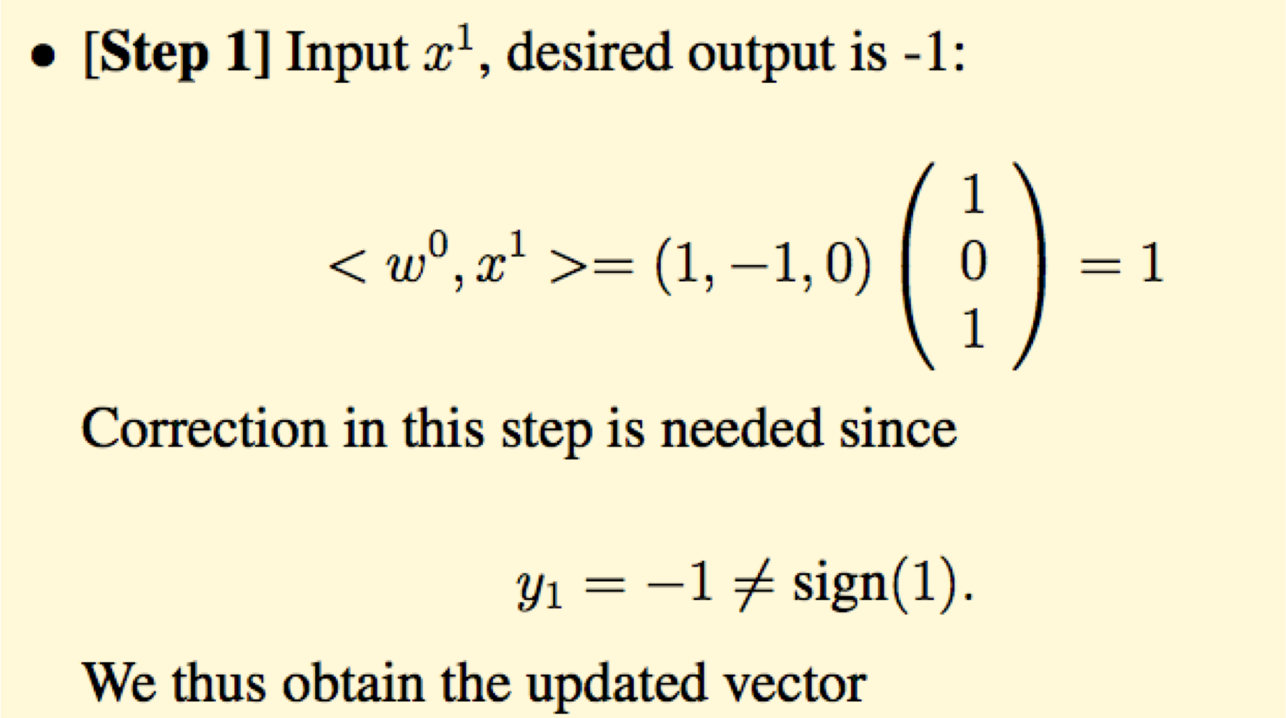

Example 2

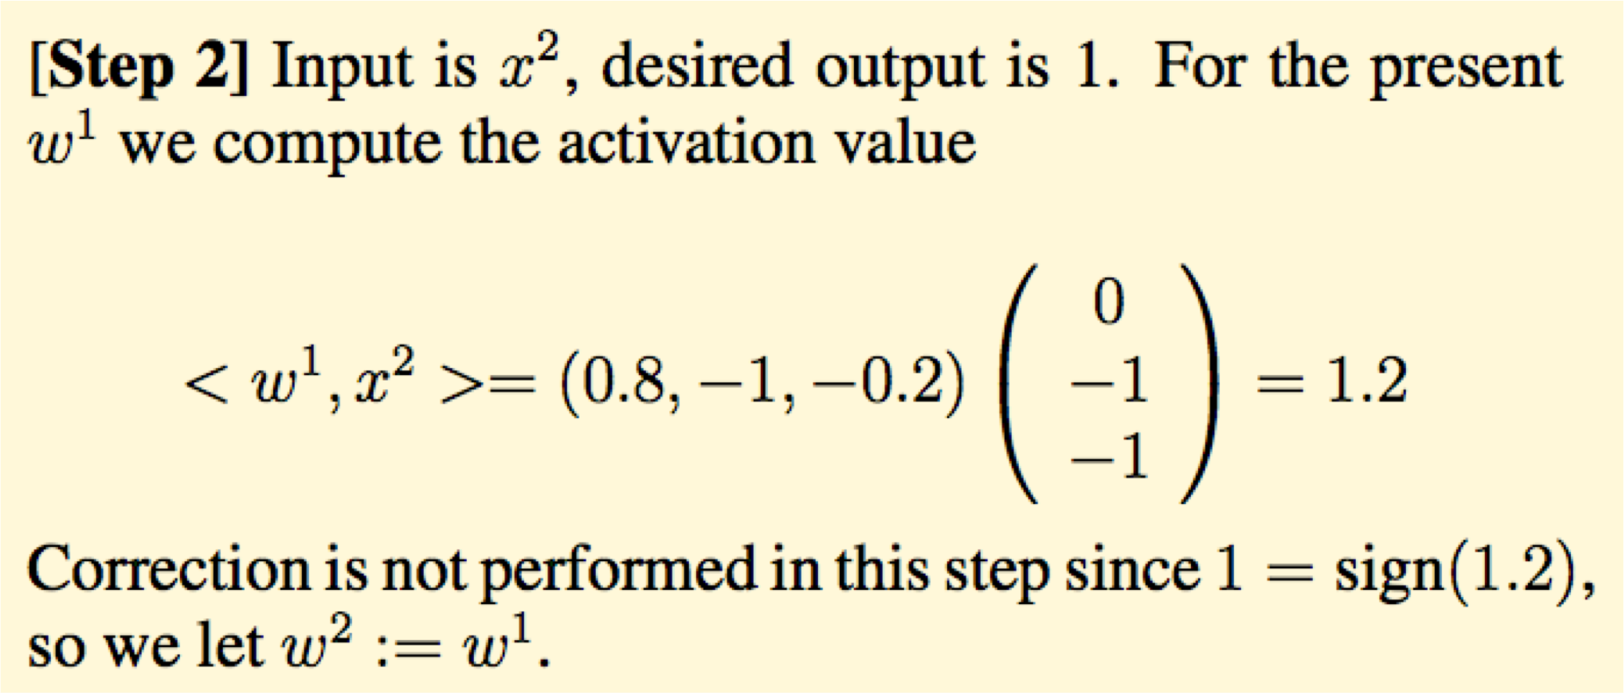

Example 2 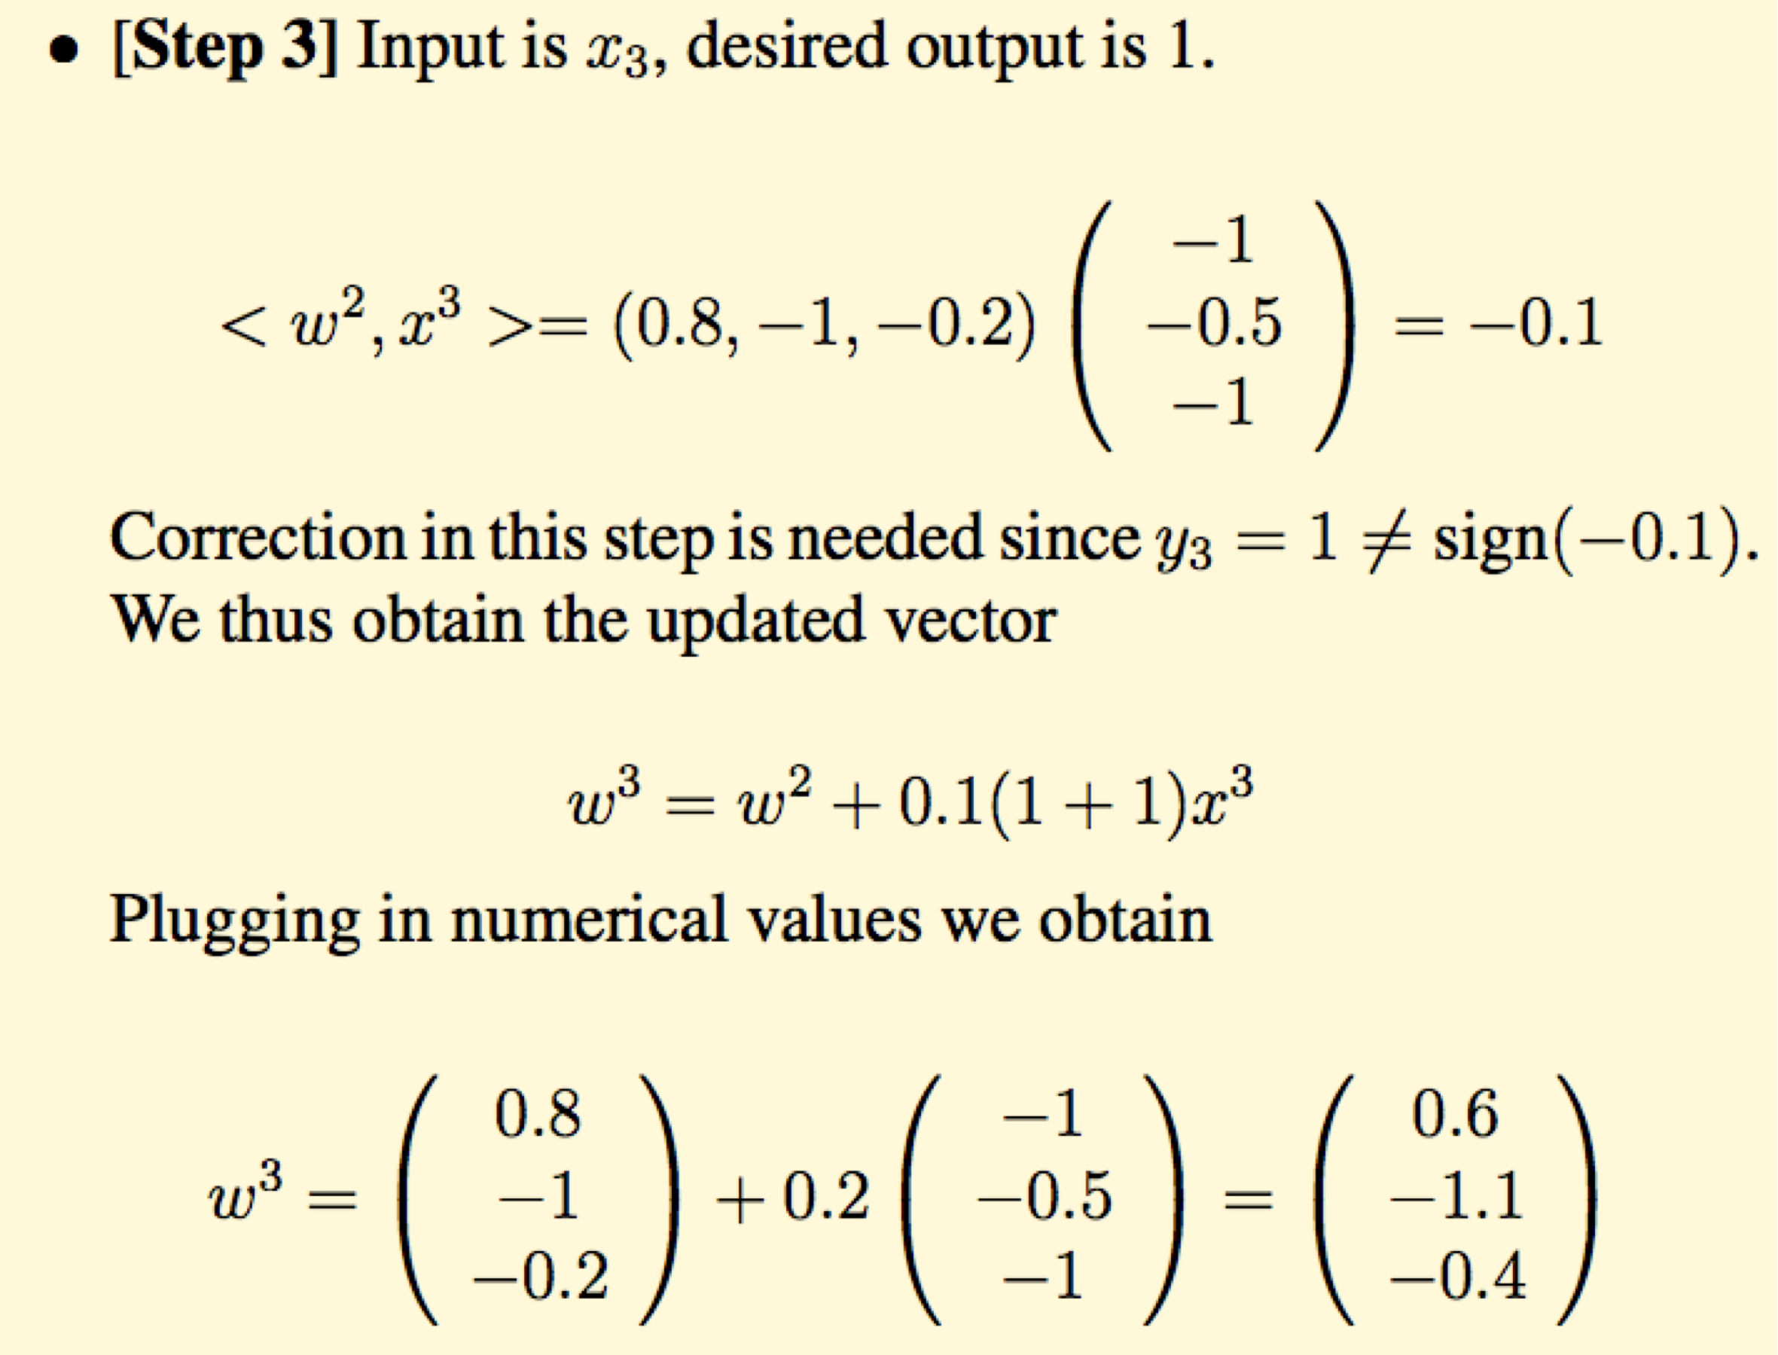

Example 2 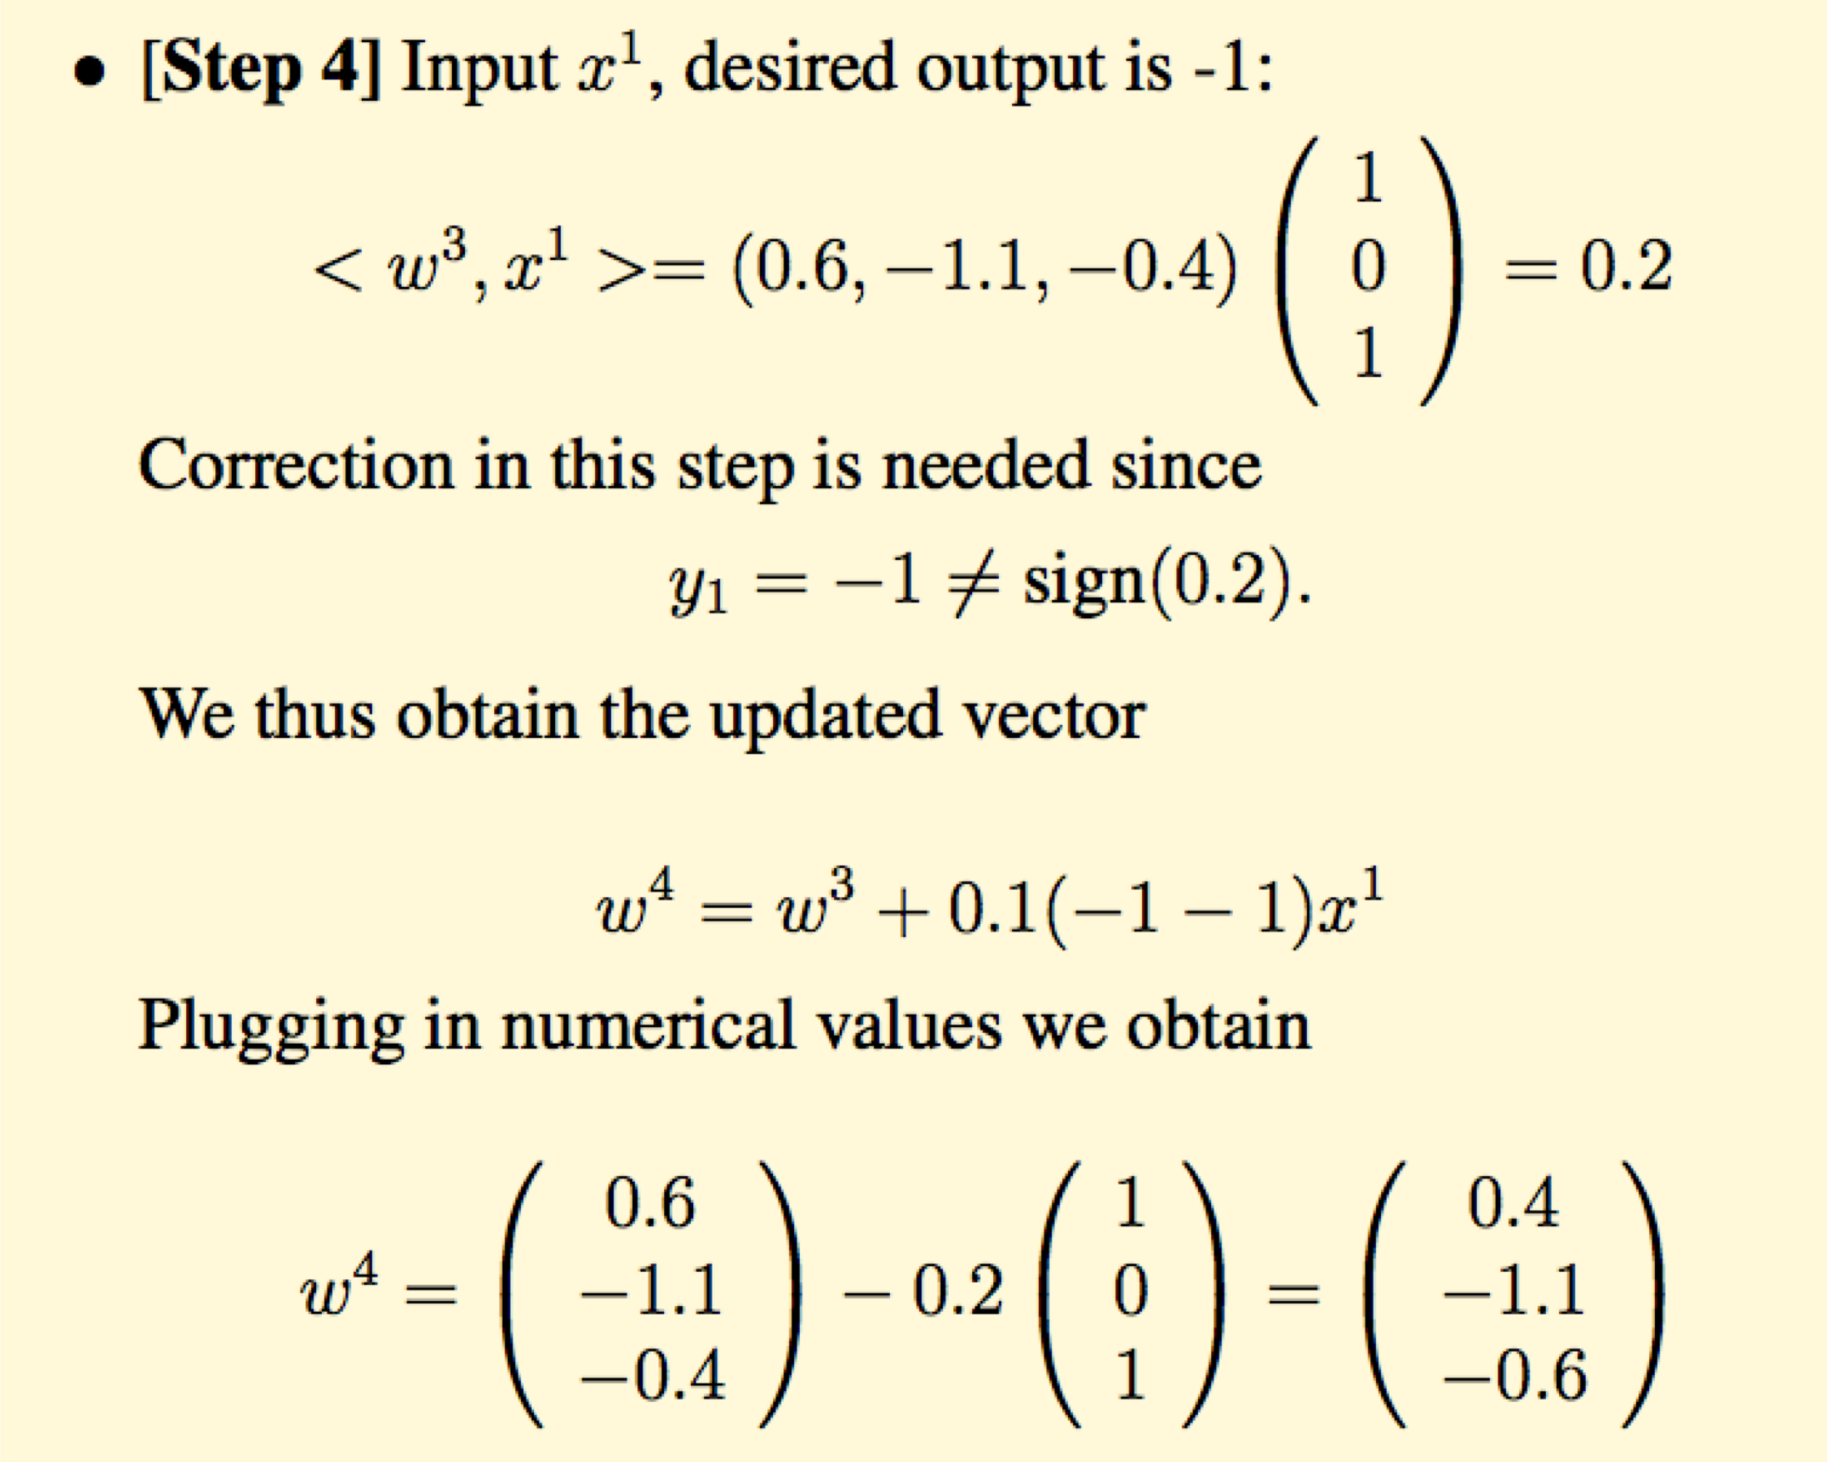

Example 2

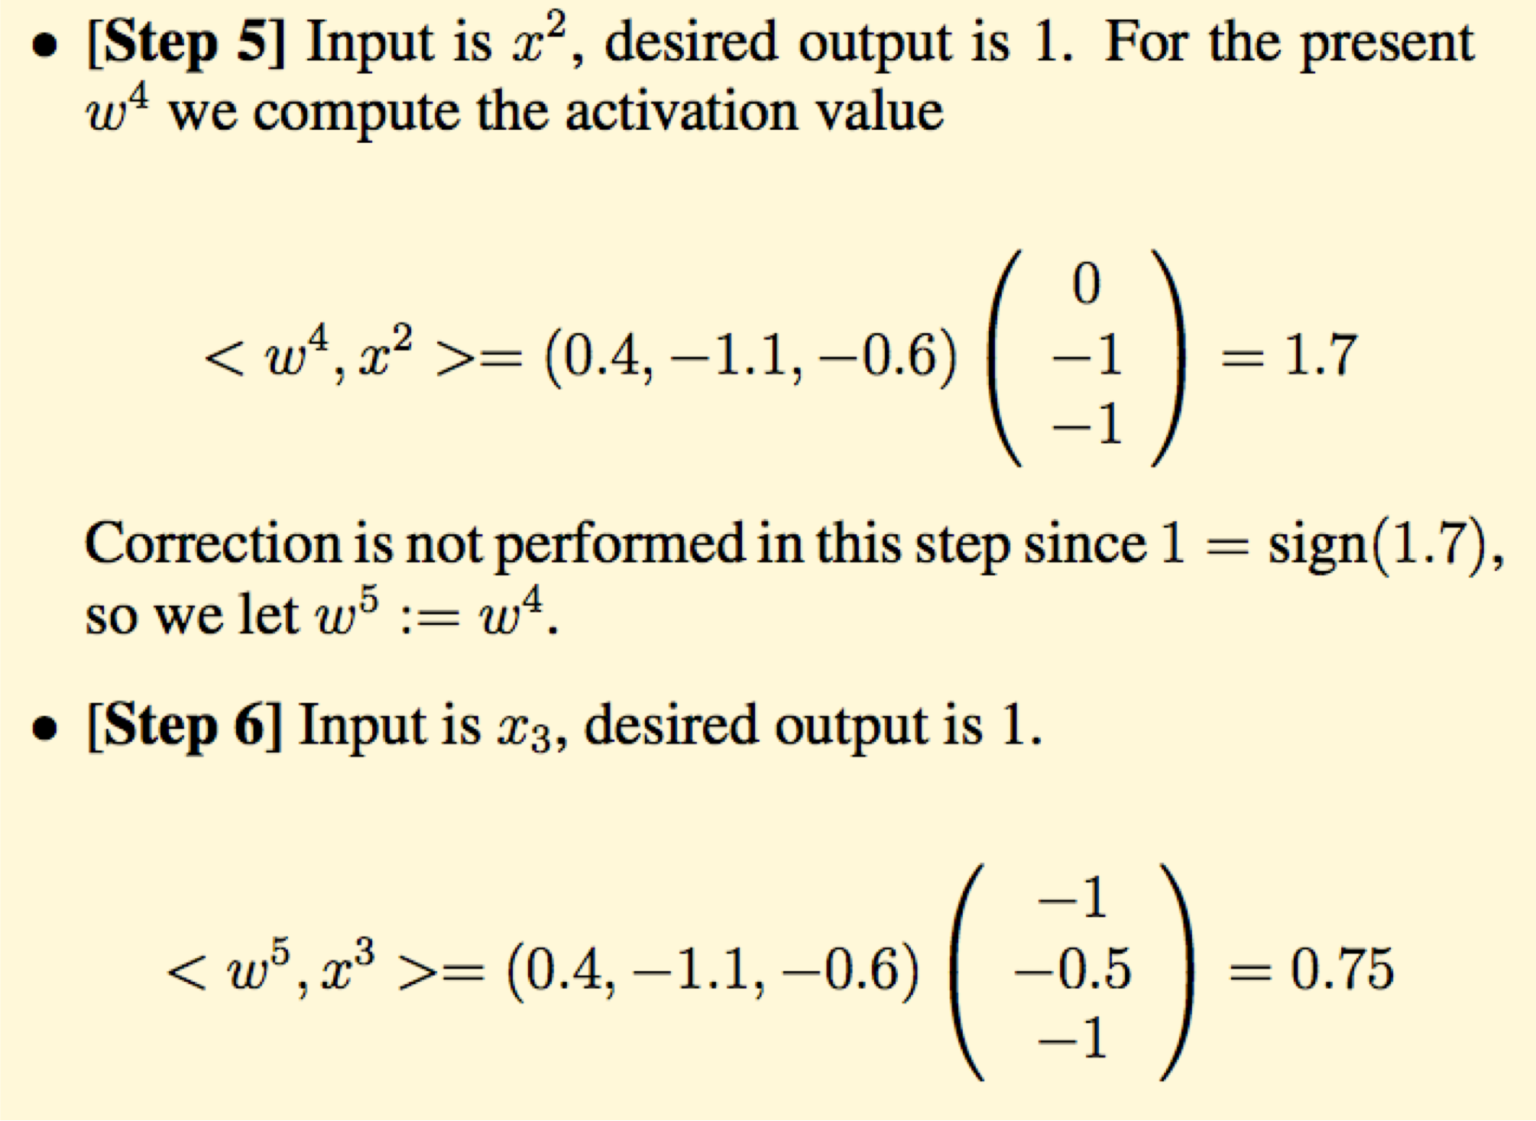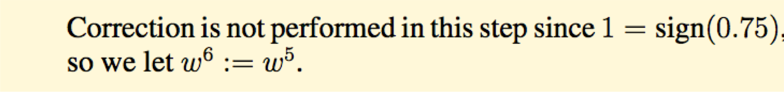

Example 2

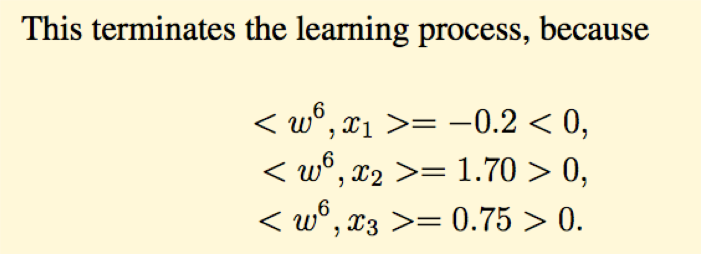

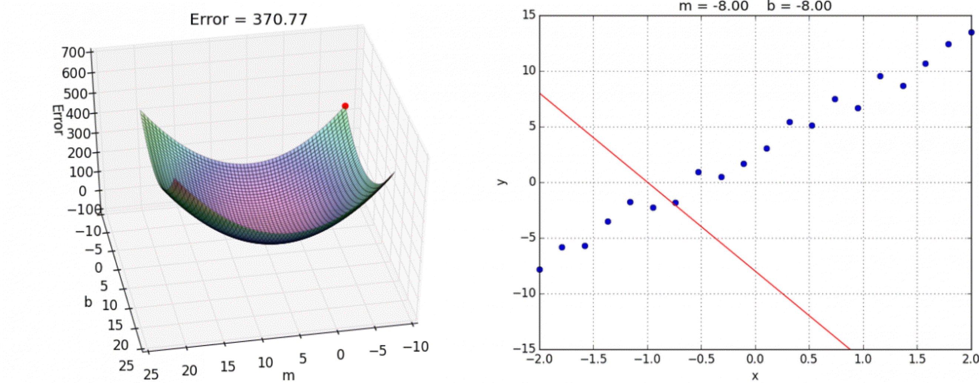

2. Gradient Descent

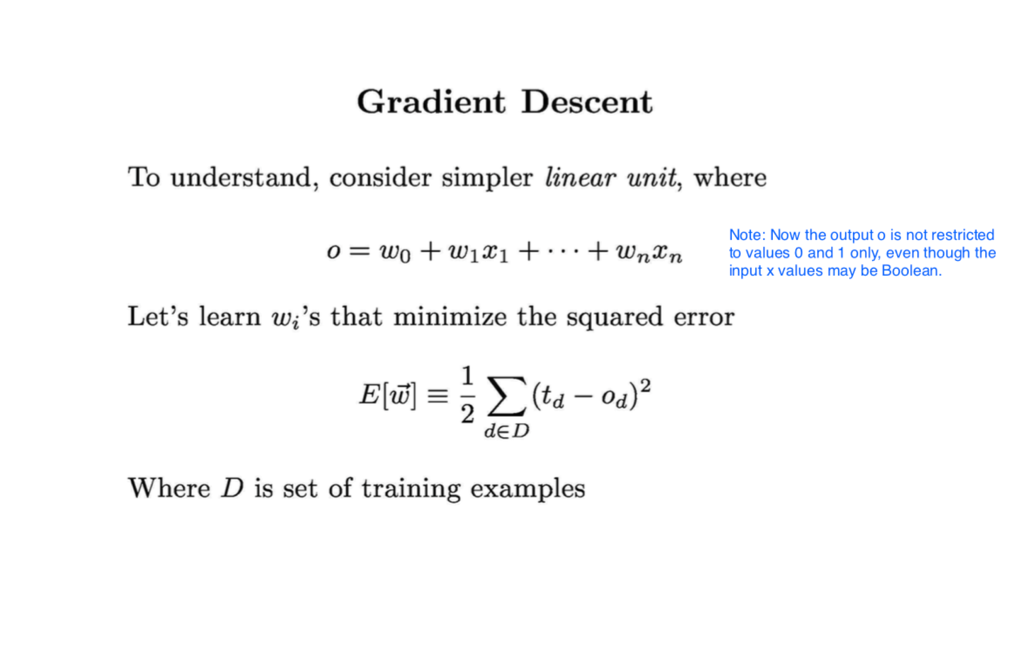

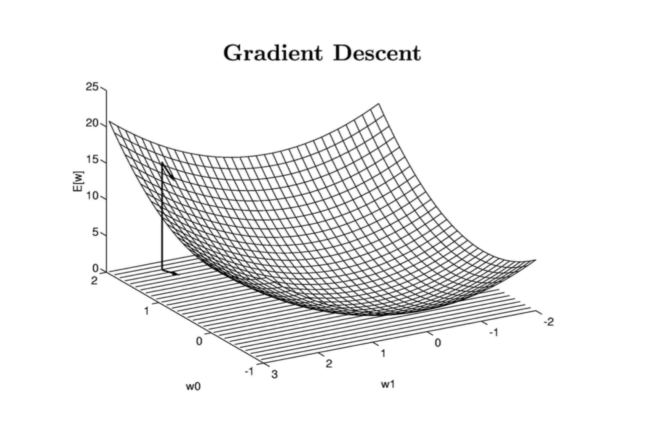

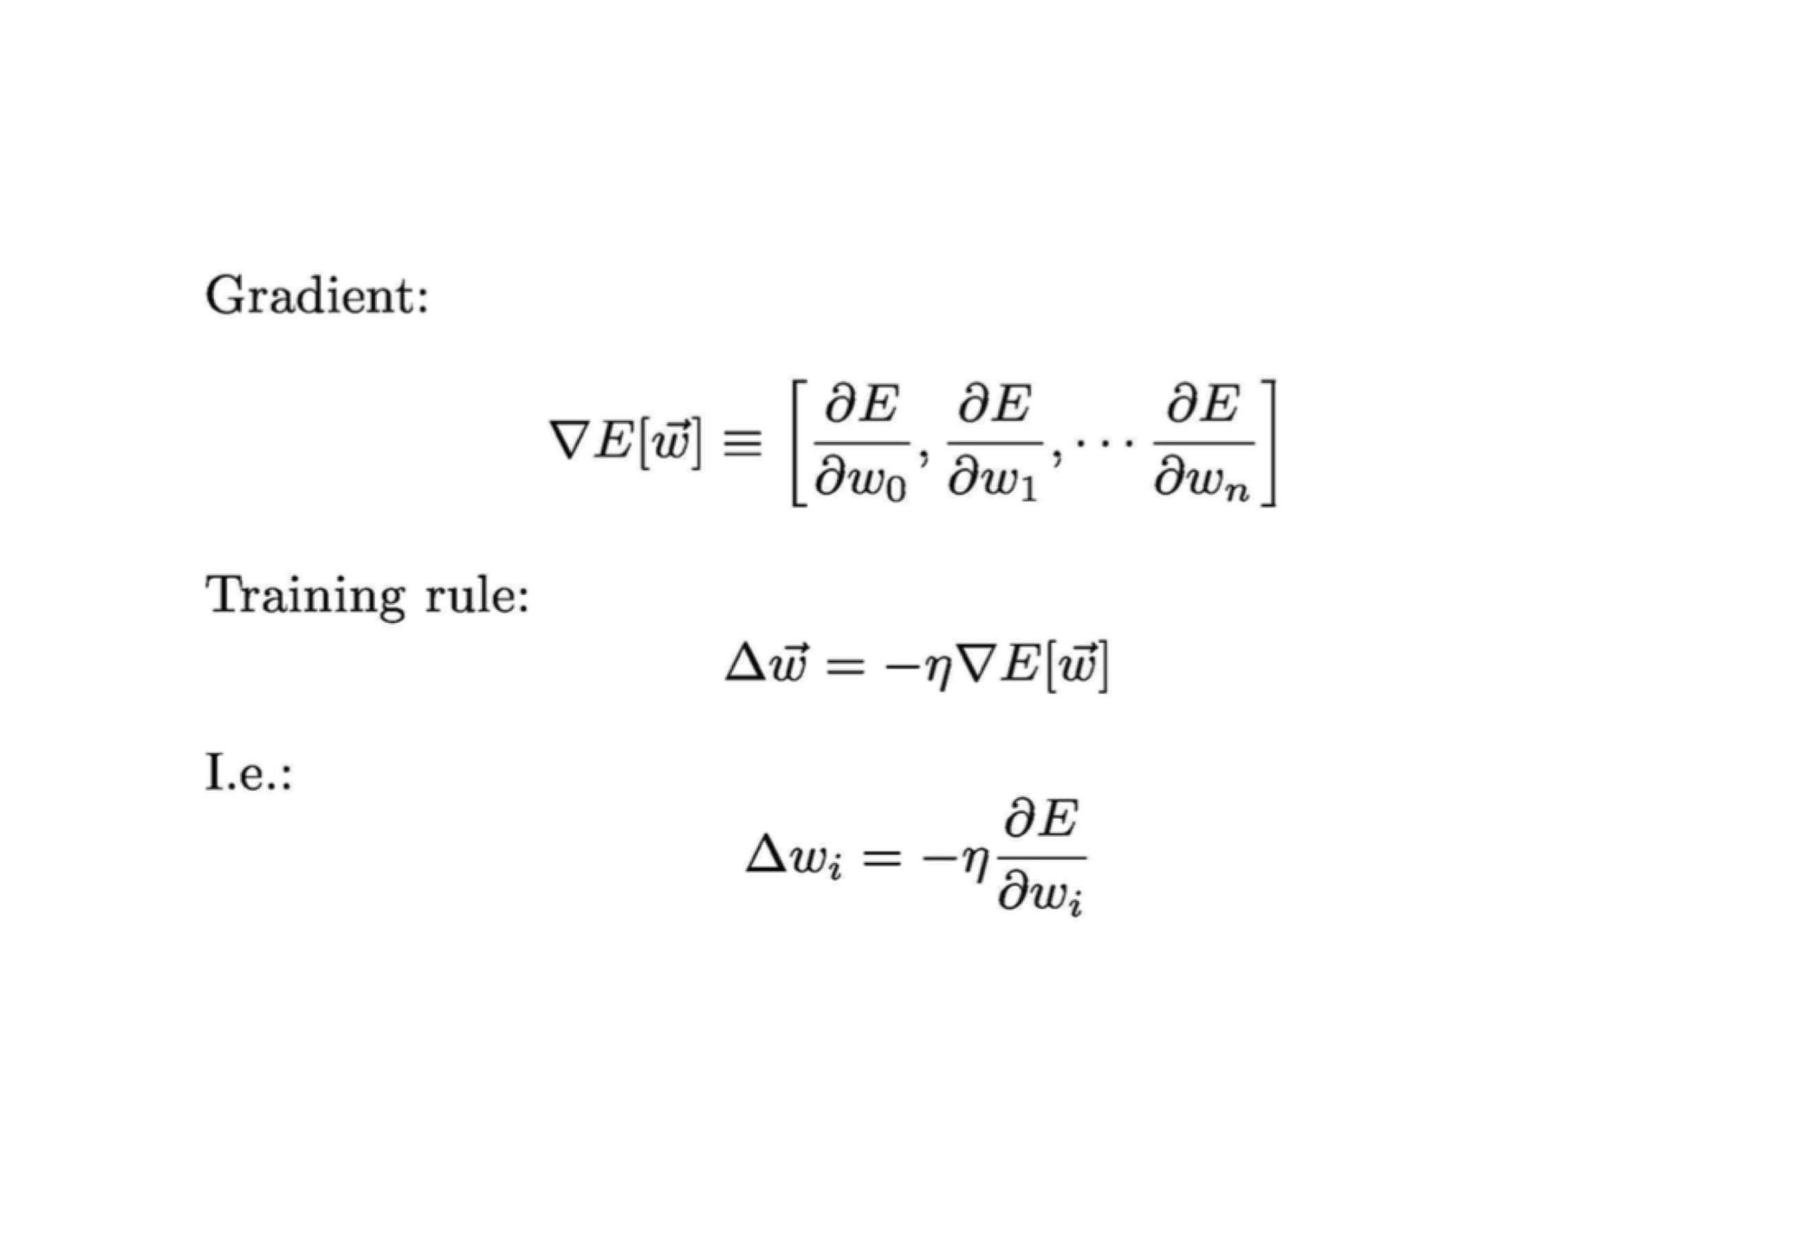

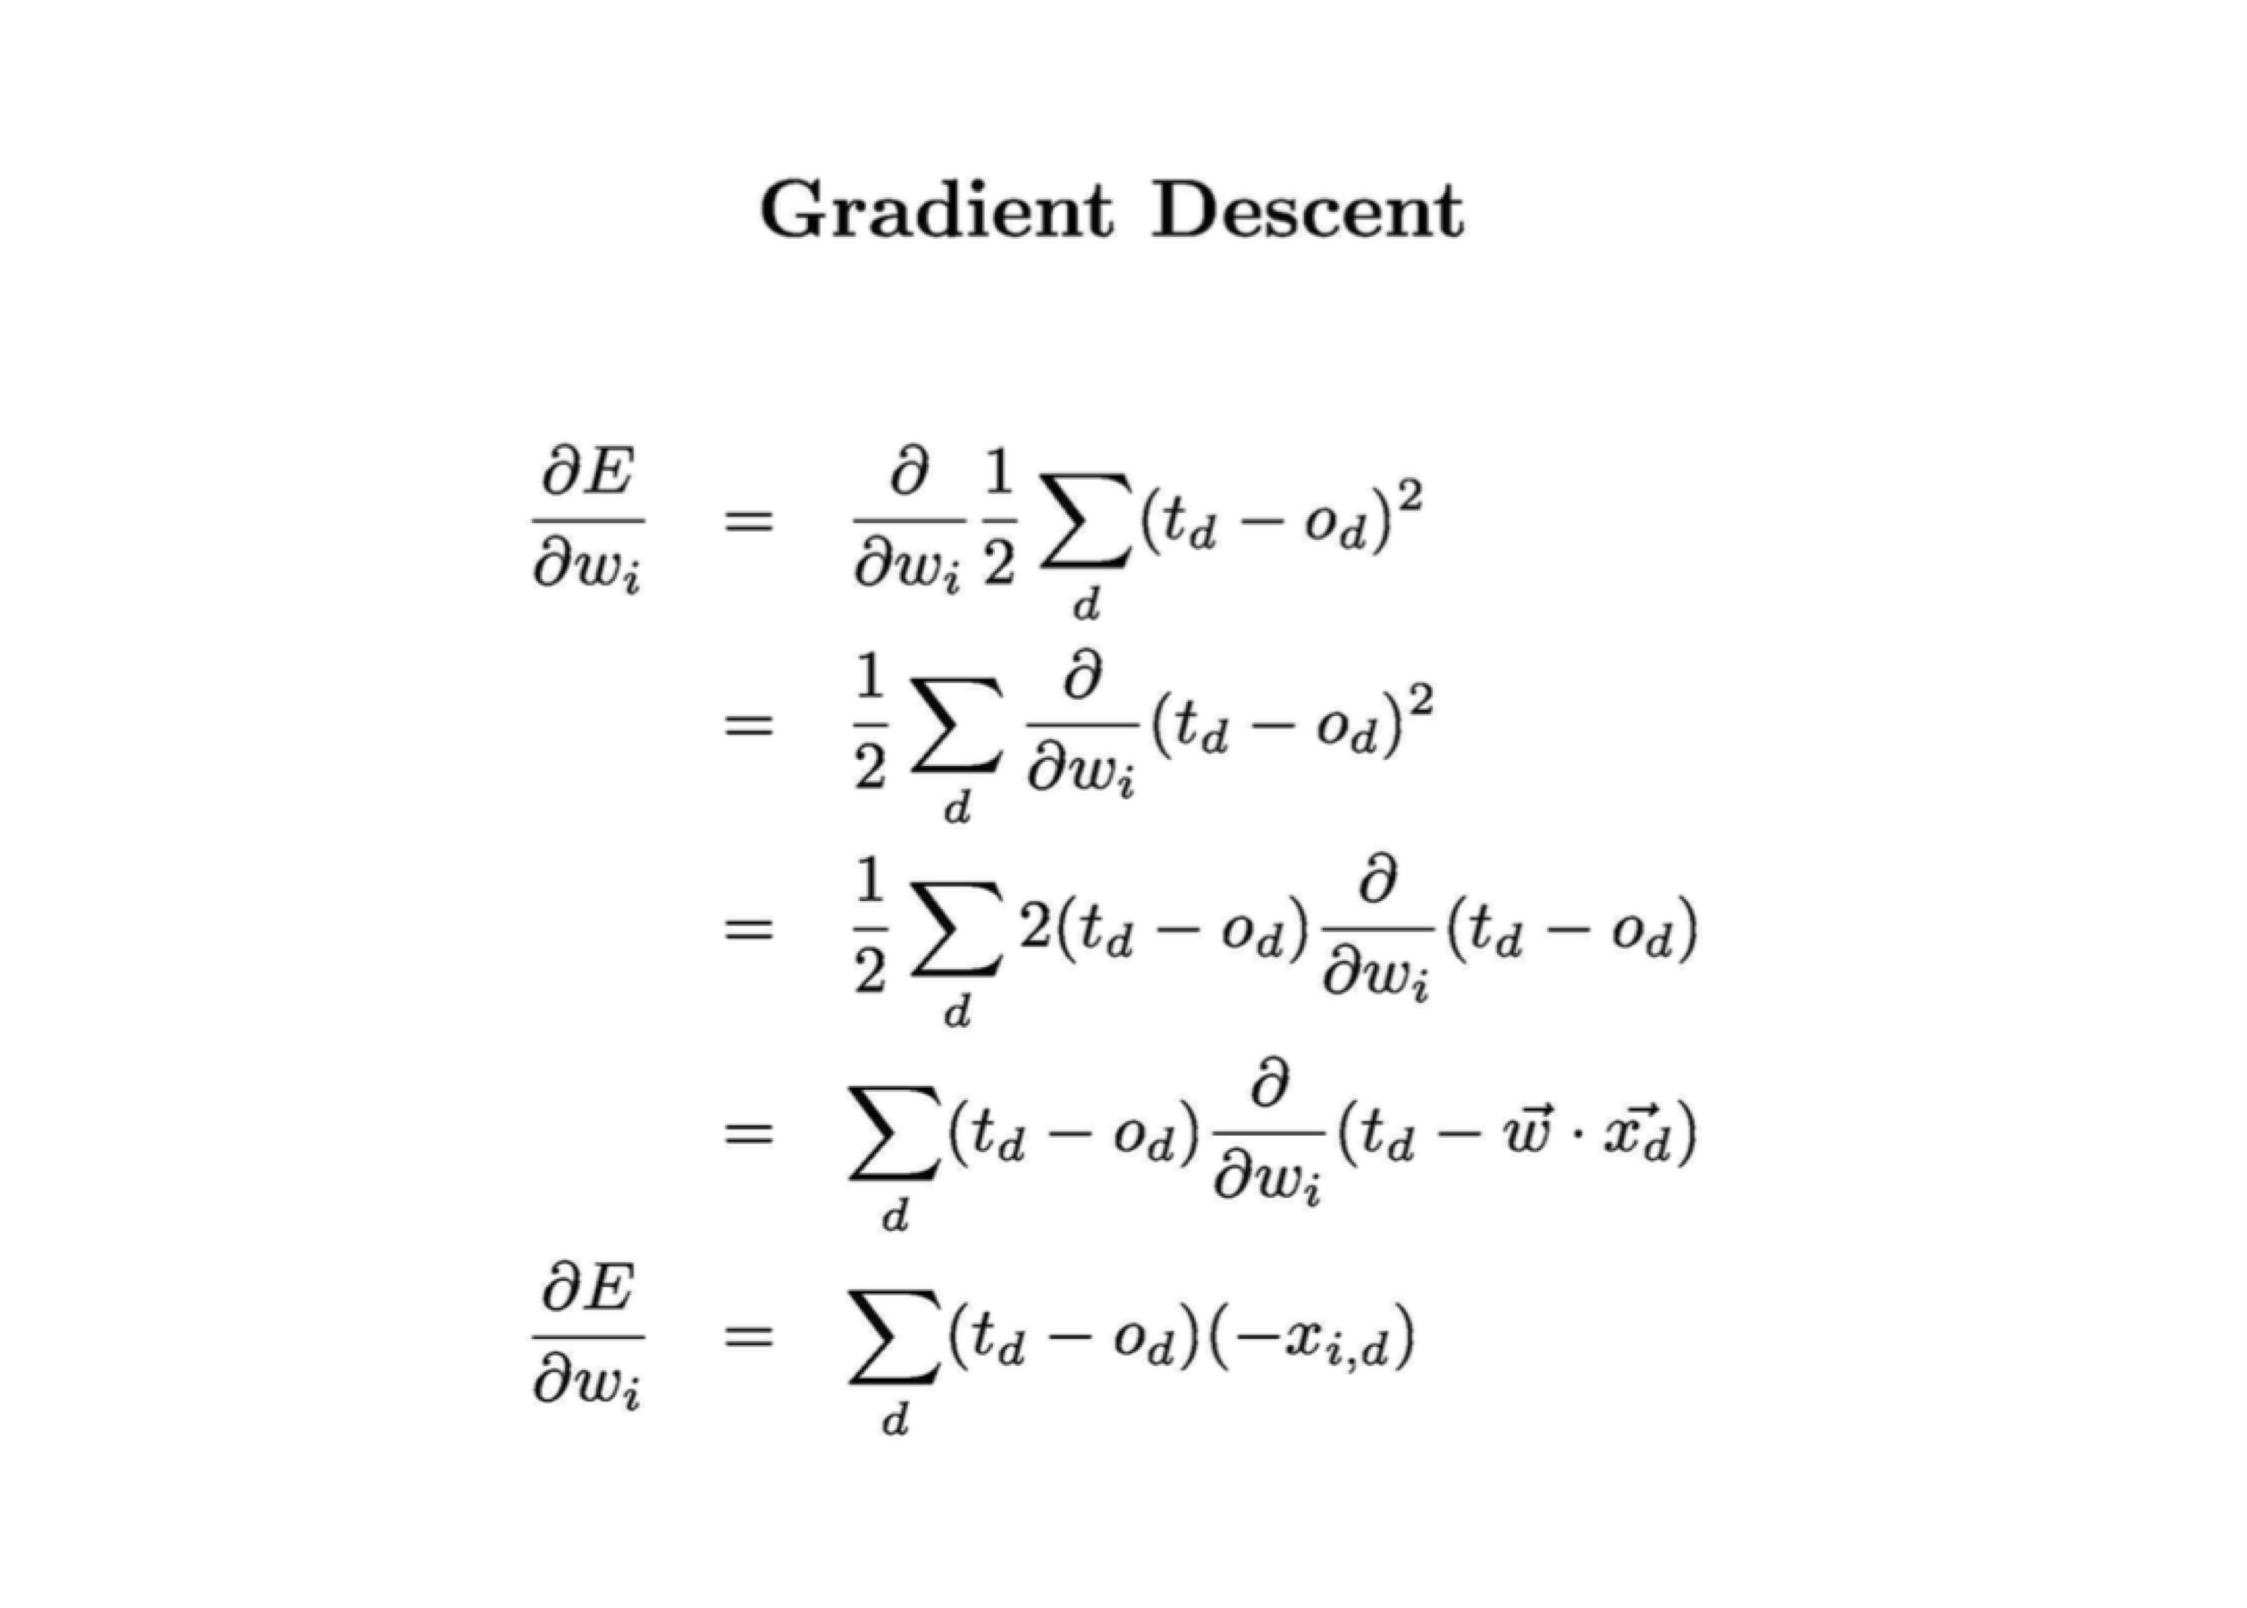

Gradient Descent

• The value of Δwi can be obtained as:

∆"# = %& *' −,'-#'

'∈)

where

% is the learning rate

*D* is the set of all training example td is the target output for the dth training example od is the actual output for the dth training example xid is the value of the ith attribute for the dth training example

# Two ways to update weights

Traditional Gradient Descent Start with a random value of w and Δwi =0 for all attributes i for all training examples x(j) {

Compute output o

Compare with t and compute each Δwi(j)

Update Δwi = Δwi + Δwi(j)

}

Update each wi as wi = wi + Δwi Stochastic Gradient Descent Start with a random value of w and Δwi =0 for all attributes i for all training examples x(j) {

Compute output o

Compare with t and compute each Δwi(j)

Update each wi as This is the wi = wi + Δwi(j) difference

}

# Difference

Traditional gradient descent can lead to:

1. Convergence to local minimum can be quite slow (many thousand of gradient descent steps)
2. If there are multiple local minima in the error surface, then there is no guarantee that the procedure will find global minimum.

Stochastic gradient descent can alleviate these problems.

(Section 4.4.3.3 of Tom Mitchell)

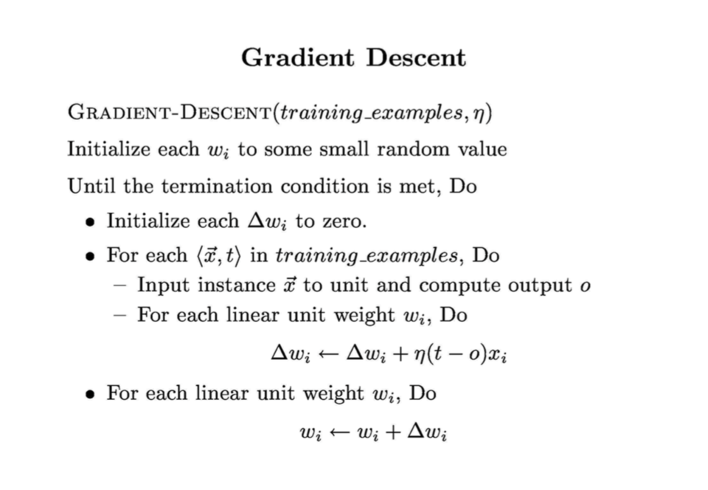

Thought Questions:

* Pros and Cons
  + Only works with linearly separable data
  + Is error driven
  + Does it converge? If you input data that is not separable, what would happen?
  + Efficient?
  + Easy to visualize
  + Can weight attributes
  + Activation function concept is nice

What is next?

* How do we extend it to non-linear datasets?